Query 1:
English Version: Create a query to list the employee id, last name, first name, and hire date for all employees who are Sales Managers.
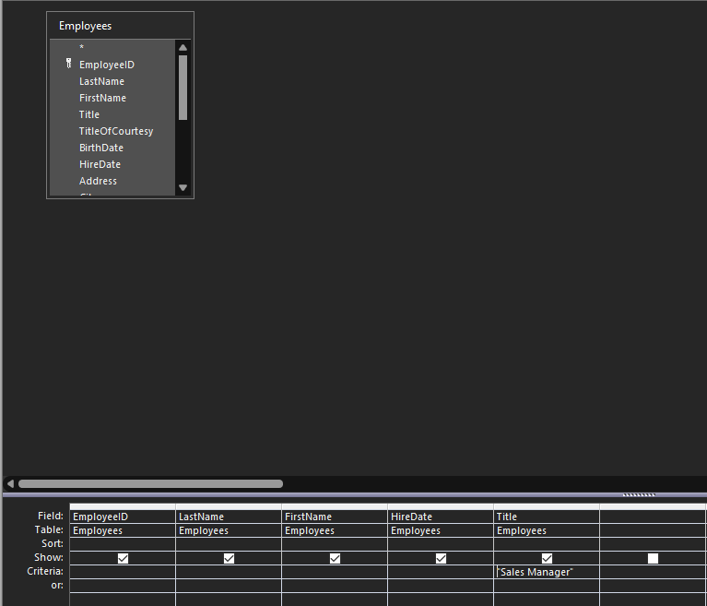
Result:
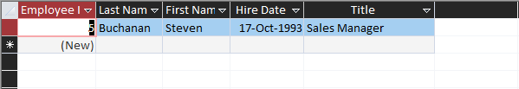

Query 2:
English Version: Create a Query that lists all employees that are from [Blank] City.
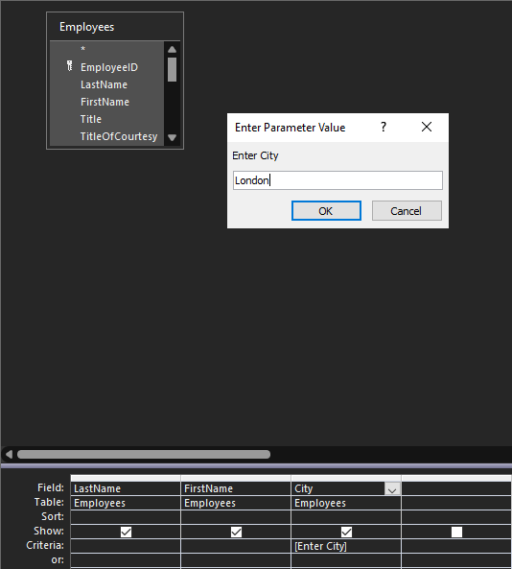
Results:
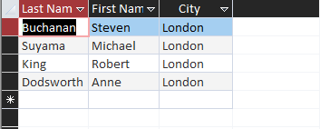

Query 3:
English Version: Create a query that shows all product id, product names, category id, and [Blank] units in stock. (Shows all out-of-stock items)
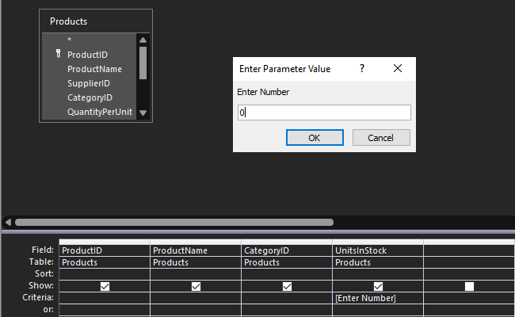
Results:
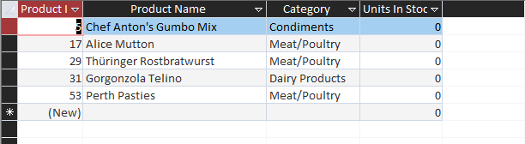

Query 4:
English Version: Query that shows all the order id, the employee id, ship via, [Blank] ship country, and [Blank] ship name.
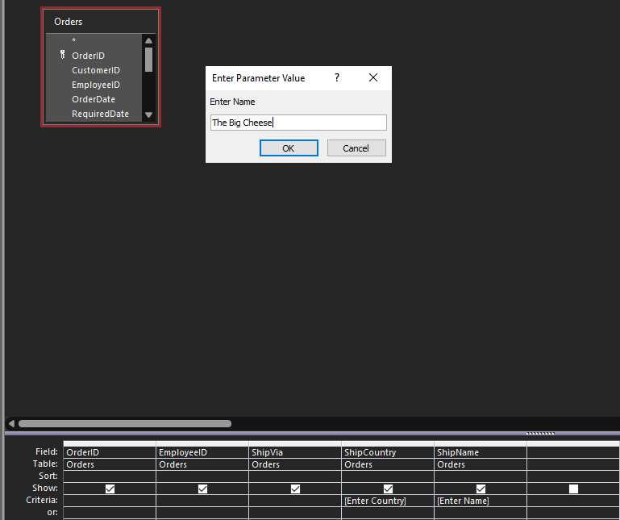
Results: (USA for ShipCountry Input)
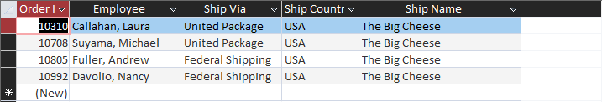

Query 5:
English Version: Query that lists all Customer id, company name, contact name, contact title for companies in [Blank] City.
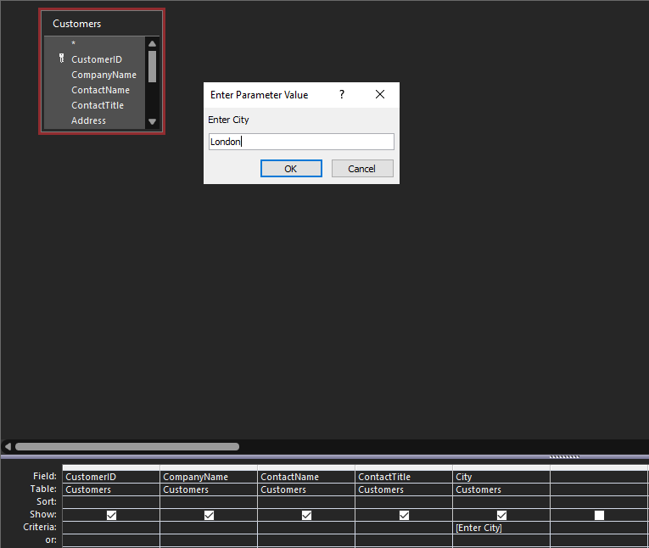
Results:
